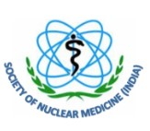
Society of Nuclear Medicine, India
C/o Radiation Medicine Centre, Tata Memorial Hospital Annexe
Jerbai Wada Road, Parel, Mumbai - 400012
Date: ______________

Voucher____________

Rs. ______________Debt. ______________________________________A/c

Paid to _______________________________________________________

Towards Student travel grant for attending 17th AOCNMB and 57th SNMICON 2025 at Chennai.

Rupees (in words) ________________________________________________

By NEFT; Dated____________________ Bank A/c no. ___________________
IFSC Code.

Hon. General Secretary Hon. Treasurer Receiver’s Signature

