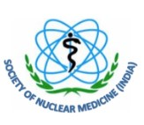

**Society of Nuclear Medicine, India**

C/o Radiation Medicine Centre, Tata Memorial Hospital Annexe

Jerbai Wada Road, Parel, Mumbai - 400012

**Date: ______________**

**Voucher____________**

**Rs. ______________Debt. ______________________________________A/c**

**Paid to _______________________________________________________**

**Towards** Student travel grant for attending SNMICON 2024 at Coimbatore

**Rupees (in words) ________________________________________________**

**By NEFT; Dated____________________ Bank A/c no. ___________________**

**Secretary General Hon. Treasurer Receiver’s Signature**